A picture containing clipart

Description generated with very high confidence

Hands-on

Adding a function trigger

UNIX/Linux Training

[**support@intellipaat.com**](mailto:support@intellipaat.com)

**+91-7022374614**

**US: 1-800-216-8930(Toll Free)**

**Adding a function trigger**

**Step 1:** Click on Add trigger

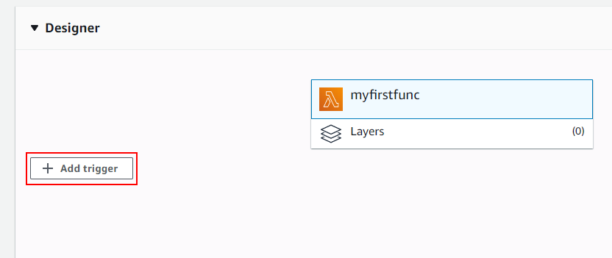

**Step 2:** Choose the trigger as S3 and fill in the other information. Choose your bucket and then choose the event type as All object create events. Then click on Add button.

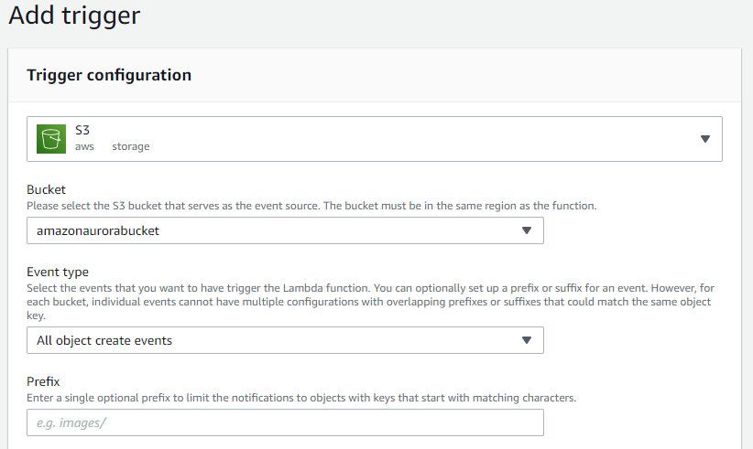

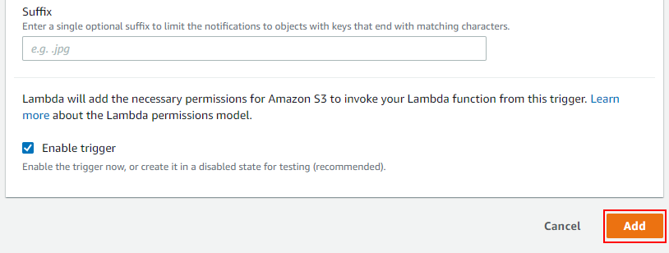

**Step 3:** Now, whenever there is an object written into the bucket. The Lambda function will execute. Now, upload a file inside the mentioned bucket. Now this should have triggered your Lambda function, which would have invoked an execution of the code.

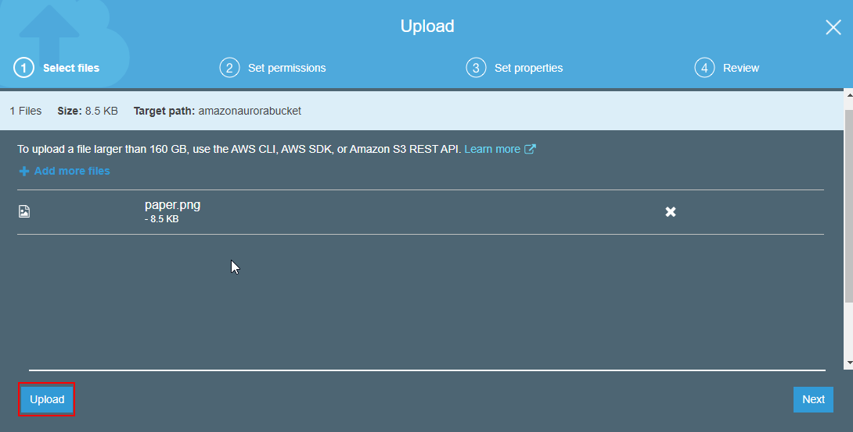

**Step 3:** Go to the Monitoring tab in the Lambda console and scroll down to CloudWatch Log Insights. You will be able to see a log stream with all the information of the Lambda function. This shows that S3 PUT operation has triggered this Lambda function.

